|  |  |
| --- | --- |
| Title | **Quality plan** |
| Description | Quality plan for the design, production, measurements, storage and transportation of Tune and Longitudinal diagnostics, Schottky Pickup for CR |
| Organization | NRC «Kurchatov Institute» – ITEP |
| Valid for: | FAIR Contract № *CC2.5.6.3.1*  Work Packages: PSP 2.5.6.3.2 |

**Document History**

|  |  |  |  |  |
| --- | --- | --- | --- | --- |
| Version | Created, date | Reviewed, date | Approved, date | Comment |
| v 1.0 | Liakin Dmitry  25.5.2020 | Date:  Signature: | Date:  Signature: | Initial release |
|  |  |  |  |  |

**Signatures**

|  |  |  |
| --- | --- | --- |
| Created, date | Reviewed, date | Approved, date |
| Liakin Dmitry  Research Scientist  Date 25.5.2020  Signature: | Date:  Signature: | Date:  Signature: |

**Table of Contents**

|  |  |  |
| --- | --- | --- |
| Preamble | 3 | |
| 1. Scope and goals of the Quality Plan | 4 |
| 2. Organizational Structure and Responsibilities | 5 |
| 3. Technical Specifications, 3D-models and Production Drawings | 7 | |
| 4. Resource Management | 7 |
| 5. Reporting Schedule | 9 |
| 6. Production and Realization | 9 |
| 7. Monitoring and Measurements | 15 |
| 8. Preservation of Products | 19 |
| 9. Control of Document, Data and Records | 19 |
| 10. Control of Non-Conformity of Products | 21 |
| 11. Professional Quality and Certification of Personnel | 23 |
| 12. Assistance: Technical Support to the Company | 24 |
| 13. Internal Quality Audits | 24 |
| Annex | 24 |
| Annex 1 | 25 |
| *ISO 9001:2015* | *25* |
| Annex 2 | 26 |
| *Specifications and Guidelines* | *26* |
| Annex 3 | 28 |
| *List of abbreviations* | *28* |

**Preamble**

This document defines the Quality Plan (QP) applied by ITEP for the design, production, measurements, storage and transportation of the Beam Diagnostic (BD) component Tune and Longitudinal diagnostics, Schottky Pickup for the FAIR Collector Ring (CR) System.

ITEP Quality Policy will be applied at all stages of the FAIR Contract No. CC2.5.6.3.1 to provide adequate control and management procedures leading to successful acceptance and commissioning of the Collaboration Contract (CC).

1. **Scope and goals of the Quality Plan**

The Quality Plan applies to preliminary design, final design, manufacturing, factory tests and inspections, delivery, final acceptance associated with the schottky pickup for the FAIR Collector Ring (CR) System.

Comprises items related to the Work Packages: PSP 2.5.6.3.2.

The detailed information about Schottky Pickup for the Collector Ring (CR) is described in detailed specification – *F-DS-BD-34e_Special_SchottkyPickup_CR_v2.5_docx_cpdf* – located at <https://edms.cern.ch/document/FAIR-CRBDX-ED-0002/2.5.1>.

**ITEP Quality Management System description**

Quality Management Service at the National Research Center “Kurchatov Institute” - ITEP has been operating since 20.08.2013, approved by the Order of the Director №200, signed August 20, 2013. The QMS (Quality Management System) implemented in ITEP meets the requirements of ISO 9001:2015. ITEP has Quality Service (QMS Service), management representative is Deputy director - chief engineer Andrey Brendelev, Head of Quality Service is Artem Belyakov (belyakov.artem.88@gmail.com).

QMS Documented Procedures:

* *Quality Manual РК СМК. 4.2.3-2013;*
* *Control of Documents СТО СМК. 4.2.3-2013;*
* *Records Management СТО СМК. 4.2.4-2013;*
* *Corrective and Preventive Actions СТО СМК. 8.5-2013;*
* *Control of Nonconforming Product СТО СМК. 8.3-2013;*
* *Audits СТО СМК. 8.2.2-2013.*

Organizational structure of QMS Department is documented by:

* *Provision on the Quality Management Service of NRC “Kurchatov Institute” – ITEP;*
* *Job description of the head of the Quality Management Service of NRC “Kurchatov Institute” – ITEP;*
* *Job description of the engineer of the Quality Management Service of NRC “Kurchatov Institute” – ITEP;*
* *Quality policy, approved by the Order of the Director №463, signed October 23, 2018.*

Organizational structure of ITEP Department is documented. Tasks, duties, rights and responsibilities within ITEP Departments are approved by the Director. Job descriptions that define responsibility and authority of experts are approved by the Director.

QMS ensures that personnel performing work affecting product quality is competent in accordance with their education, training, skills and experience.

Measures and instructions for personnel involved in the production process are in compliance with provisions of QMS applicable plans and applied both for ITEP staff and its subcontractors.

The QMS allows to:

* Determine the necessary competence for personnel performing work affecting product quality;
* Provide training or take other actions to satisfy these needs;
* Evaluate the effectiveness of measures;
* Create awareness of its staff on the relevance and importance of their activities and contribution to the achievement of quality objectives;
* Maintain appropriate records of education, training, skills and experience.

**ITEP ISO certificates**

The ITEP QMS has been audited and certified by Federal Agency on Technical Regulating and Metrology Voluntary Certification System “Alpha Register” in accordance with requirements of the management system standards **ISO 9001:2015**. Certificate of conformity № СДС.АР.СМК.02022-18 dated 14th September, 2018. The certificate is valid until 14th September, 2021. The certificate covers design, construction (including Research, Development and Engineering works) of nuclear power facilities and equipment; nuclear instrumentation and units; accelerators of proton and various types of ions and constituent components; detectors and units for the experiment on superdense baryonic matter; medical equipment; solid scintillation antineutrino detector; construction, reconstruction of space infrastructure and systems; theoretical, experimental and applied works in the field of structural materials in nuclear power engineering; development of documentation, methods and instruments for testing, commissioning and decommissioning, adjustment, repair and disposal of products; designer supervision and technical support; development of software products, see Annex 1.

1. **Organizational Structure and Responsibilities**

**Distribution of responsibilities**

ITEP Acting Director *Igor Bozhkov* has ultimate responsibility for the quality of products and services provided by ITEP to FAIR.

**Project management structure**

*ITEP coordinator*

Name: *Dr. Timur Kulevoy*

Position: Deputy Director for science (accelerator physics)

Email: [kulevoy@itep.ru](mailto:kulevoy@itep.ru)

Tel.: +7910402-2483

The Coordinator is responsible for:

* Ensuring communication between ITEP and FAIR;
* Monitoring of scientific and technical progress of the Collaboration Contract activities;
* Coordination of work on the Collaboration Contract with different departments at ITEP;

*Work Package Leader (WPL)*

Name: *Dmitry Liakin*

Position: Research Scientist

Email: [liakin@itep.ru](mailto:liakin@itep.ru)

Tel.: (+7) 499 789 6554

The Project Manager is responsible for:

* Schottky Pickup design (3D-models, production drawings);
* Development of the technical documentation and manufacturing drawings for the deliverables;
* Ensuring that the production of the system is according to the technical specifications and time schedule;
* Follow-up of production activities;
* Validation of the achievements at the defined milestones;
* Control of the documents to be delivered to FAIR;
* Regular and timely reporting on progress and problems;
* Timely conduction/participation of reviews and provisions of feedback;
* Factory Acceptance Test (FAT) and Site Acceptance Test (SAT) to verify the given specifications of the components;

*QMS Service*

Name: Artem Belyakov

Position: Head of QMS Service

Email: [belyakov.artem.88@gmail.com](mailto:belyakov.artem.88@gmail.com)

Tel.: +7903790-8234

The Head of the QMS Service is responsible for:

* Quality assurance and control over proper execution of deliverables in compliance with the Quality Plan;
* Internal Quality Audits.

*Economics and finance*

Name: *Irina Balakina*

Position: Deputy Director for economics and finance

Email: Irina.Balakina@itep.ru

Tel.: (+7) 499 789 6500

The Deputy Director for economics and finance is responsible for:

* Economic and commercial issues, including customs-related issues.

1. **Technical Specifications, 3D-models and Production Drawings**

* Conceptual design will be based on the technical specifications (Annex 2).
* Conceptual design will be presented in 3D-models. Conceptual design will be approved by FAIR. 3D-models will be uploaded to EDMS.
* Production drawings will be based on the conceptual design. Production drawings will be approved by FAIR before starting of components manufacturing. 2D-drawings will be uploaded to EDMS.

1. **Resource Management**

**Personnel**

The organizational structure of ITEP is shown on Figure 1.

ITEP has QMS Service, management representative is Deputy director - chief engineer Andrey Brendelev, Head of Quality Service is Artem Belyakov ([belyakov.artem.88@gmail.com](mailto:belyakov.artem.88@gmail.com)).

ITEP’s Accelerator Center, management representative is Deputy Director for Accelerator Research Timur Kulevoy, Head of Accelerator Center is Nikolay Alekseev.

**Infrastructure**

Scheme of ITEP’s Accelerator Center is shown on Figure 2. It include several buildings with main ring accelerators hall, several injectors of protons, light and heavy ions, set of target halls, several engineering zones for developing and testing accelerator’s equipment and more than 100 offices.

**Machines and equipment**

The Departments of Accelerator Center have a set of appropriate equipment for mechanical, vacuum and electrical testing and tuning of diagnostic vacuum chamber with mounted diagnostic elements, as well as testing and tuning of analog and digital electronics.

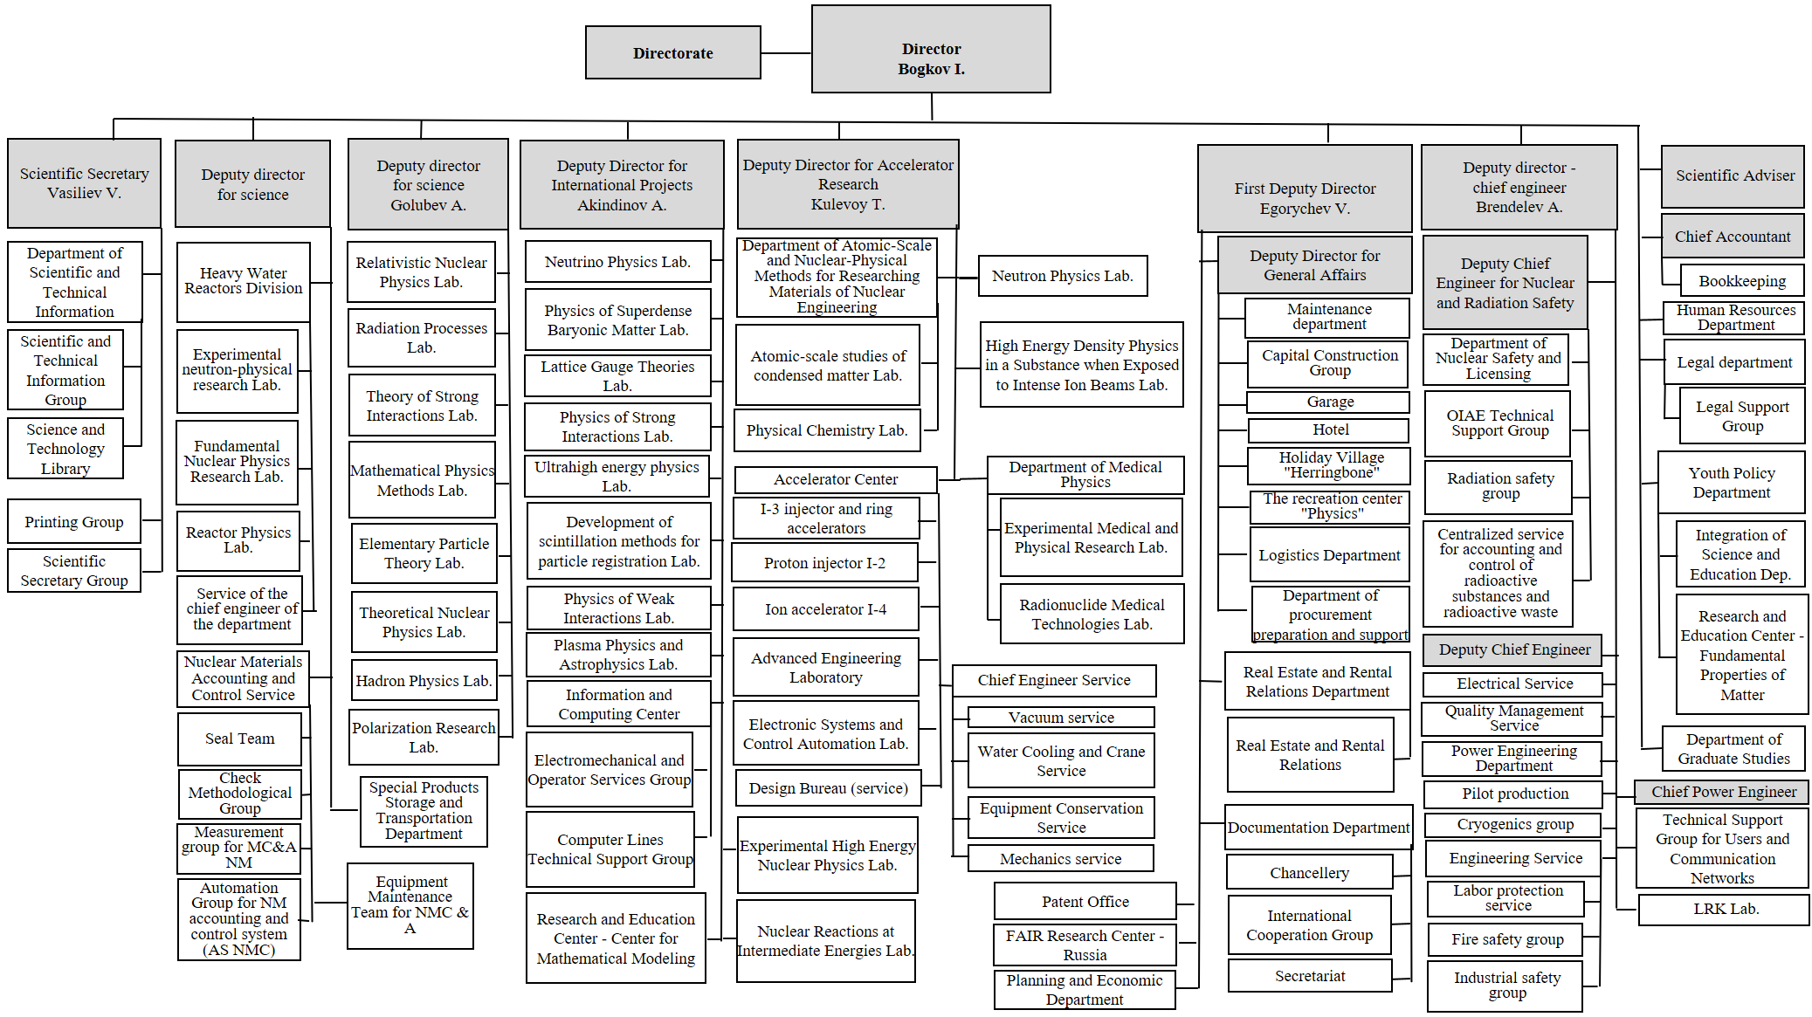

Figure 1. ITEP Structure.

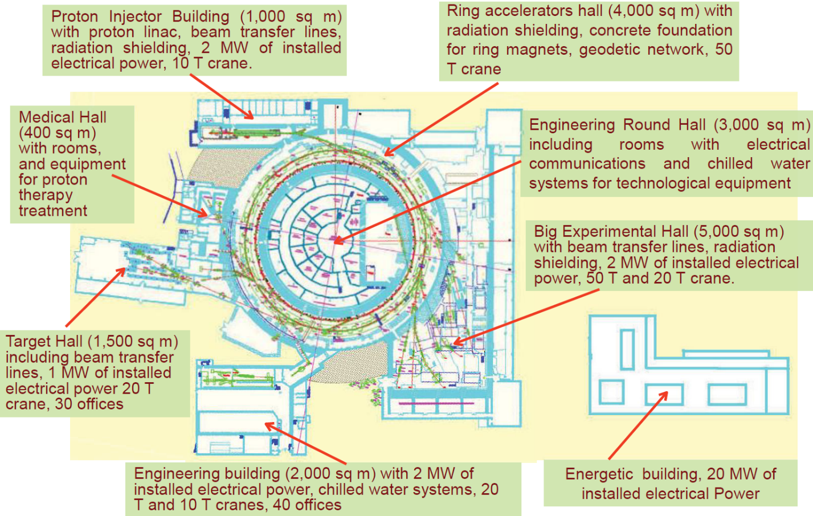

Figure 2. ITEP’s Accelerator Center.

1. **Reporting Schedule**

ITEP and FAIR/GSI personnel will monitor the scientific and technical progress of the Contract activities. Reporting by ITEP will keep the following schedule:

* Progress reports – every month;
* Video conferences – once a year;
* Project reviews – 4 (four) times a year at the start-up of the Contract (before series production);
* Meetings – once a year.

1. **Production and Realization**

**Purchase and procurement process**

Four departments of ITEP engaged in purchasing: the Planning and Economic Department, the Department of Procurement Preparation and Support, the Department of Logistics, the Legal department.

All the departments are subject to the *Regulation on the acceptance of goods, works and services in quantity and quality at ITEP*. The Legal Department monitors compliance and participates in procurement.

The Project Manager is responsible for general management of the project procurements. The Quality assurance specialist is responsible for quality control of suppliers and for the acceptance of goods for the project (for the Department of Logistics).

**Control of subcontractors**

ITEP makes an assessment of the subcontractors in terms of equipment, personnel and specific competences, and of its experience in relation to the estimated difficulties of the intended subcontracted tasks.

ITEP QMS Service and purchasing departments by means of incoming tests carry out control of subcontractors in accordance with the QMS documents.

ITEP may set quality requirements to its subcontractors, however, it does not relieve ITEP from its responsibility to ensure quality of the supplied products.

If necessary, the QMS service can conduct audits of suppliers for compliance with ISO 9001:2015. 3 employees of the QMS Service have successfully completed the course assessment and examination for the ISO 9001:2015. The date of the last training of expert auditors is September 14, 2018, based on the decision of the certification commission in the ALFA REGISTER voluntary certification system, protocol No. 2630-18 of September 14, 2018.

**Manufacturing process chart**

The Schottky system is divided into two structural subsystems. From the production point of view the mechanical assembly and the electronic system are independent from each other. Therefore, two charts of the production sequences are presented below in Figure 3 and Figure 4.

The mechanics components are a) the vacuum chamber arranged with flanges and half-nipples of the signal feed through and b) the electrodes with a system of positioning elements. All could be produced by the institutional workshop stuff. In same time, it is economically reasonable to use of commercial components such as CF flanges, nipples, vacuum RF connectors. For the insulators we have chosen a standard item from the nomenclature of one of ceramics supplier.

The first vacuum test is performed when the volume is closed, i.e. when the chamber is welded with flanges and nipples.

The electrodes and their holding elements are manufactured together with required positioning tools. These tools help to fix the holding elements in proper position inside the vacuum chamber for welding them together. The fine tuning of the electrodes position is performed with screw mechanism. Therefore, the requirements to the holder accuracy are quite relaxing. Nevertheless, after welding of the holder components, the assembly will be checked for the correspondent tolerance conformities.

Materials, flanges, nipples, insulators

Chamber welding

Vacuum leakage test

Screw assembling

Holding system components production

Welding of the holding system

Electrodes

Mechanical adjustment of electrodes position

RF-based adjustment and test

Vacuum test

FAT

SAT

Figure 3. Schottky mechanics production chart.

The electrodes must be adjusted as a part of a radiofrequency system. A low RF reflection should be achieved at highest applied frequency at signal (downstream) ports. The method of electrical matching and test procedures are described below in this document.

Manufacturing and purchasing of cases and boxes

Purchasing of components, ADC and DSP boards

Printed boards design and production

Assembly and test of analog electronics

System assembly and overall test

Analog Proc. & Data Acquisition tests

Figure 4. Schottky electronics production chart.

The work packages to be delivered are:

*Pickup (at beam line)*

* One diagnostic vacuum chamber with flanges
* Four sensor plates (two per detection plane) with strip line geometry and 50 Ohm characteristic impedance mounted on diagnostics vacuum chamber
* Four isolated mounting elements for all sensor plates
* Eight 50 Ohm matched and rf compliant signal connections between sensor plate and vacuum feed-through
* Eight UHV signal feed-troughs (two per plate ) with N-type female connectors on the air side
* Eight pull reliefs
* Four ground plates (integrated in vacuum chamber walls or tunable for 50 Ohm matching).
* Girders and supports

*Electronics (low radiation area)*

* Four 50 Ohm power loads for plates termination
* Protection circuit against electrostatic charge onto the sensor plates
* Four low noise amplifiers (with bypass) for plates signal amplification
* Power supply for amplifiers
* Cables for interconnections between pickup and amplifiers

*Electronics and DAQ (electronic room)*

* Four splitters for connecting amplified signals from low noise amplifiers to different types of signal processing
* One analog signal processor unit for signal normalization and conversion to sum and difference signals
* One digital signal processor unit as signal measurements and analysis DAQ system with software interface for the data and for the control of electronics
* One signal combiner for preparing signals from splitter for real-time spectrum analyzer by conversion to sum and difference and remotely controlled 4:1 switching
* Coaxial cables for all connections between Electronics components and interconnections to the DAQ components
* Multicore cables for controlling the bypass of amplifiers and control of RF switches
* One industrial PC compatible with all pre-requisites to run FESA and with interface to control the electronics
* Racks for electronics

**Identification and traceability**

The schottky pickup name is a drawing number and serial number which will be written on the one of the marker label (not less than 7 mm in font). The schottky pickup have to be labeled with a metal tag containing a QR codes, the tags will be supplied by FAIR/GSI.

Traceability will be provided by QMS and the Department of Logistics documents.

Product identification includes marking and labeling of the components and complete products as well as design and manufacturing documentation. The documentation provides traceability of use and location of these products for the purpose of detecting possible reasons of manufactured product non-conformity or imperfections of the manufacturing processes.

Traceability is obtained by marking and labeling of identification objects, accompanying documents, registration of identifications data during production process beginning by receiving components and finishing by packing and sending the product.

Marking and labeling of the identification objects should be included in the subcontractor’s manufacturing process and are regulated by the design and manufacturing documentation. Manufacturing documentation contains the necessary and sufficient information. The identification processes continuity is provided, and the processes are accessible and maintained through the full manufacturing and warranty periods.

Identification data are recorded at all stages starting from procurement and including the stages of the materials production start-up or the half-finished products, the components transfer to the storehouse or to related production hall for successive processing, quality control of manufactured components or assemblies, registration and isolation of non-conformity products.

Identification and traceability action cover the main production stages:

* products identification during input tests;
* products identification during manufacturing;
* products identification during inspection and testing;
* products identification during packing and storage;
* products identification during delivery to the customer.

Requirements specified for the components, units and assemblies marking are given in the drawings. A method of marking is specified in the manufacturing documents. Requirements are specified in the appropriate drawing and are checked during requirements inspections.

**Tools, techniques, equipment and methods**

Tools, techniques, equipment and methods will be defined finally during the first article production.

Tests for the main production phases:

* Material quality control;
* Vacuum tests of welds and assembled vacuum vessel;
* Electronic components tests.

Meanwhile, the RF test could be described as followed.

The impedance matching is provided by changing of the wave impedance of the electrodes by varying the distance *d* (see Figure 5) between the electrode and the inner surface of the vacuum vessel.

NA

R0

R0

R0

*d*

R0reference

A

Beam upstream side

Figure 5. Impedance test of Schottky antenna. The configuration with four ports.

The goal of RF tuning is matched impedance system. Due to the network analyzer (NA) principle of operation the impedance is compared to the reference value in zero-crossing mode or substitution method. It reduces the accuracy requirements to the network analyzer itself. The dominated component of the measurement error is an impedance inaccuracy of the assembly of the reference terminal resistor and connected adapter.

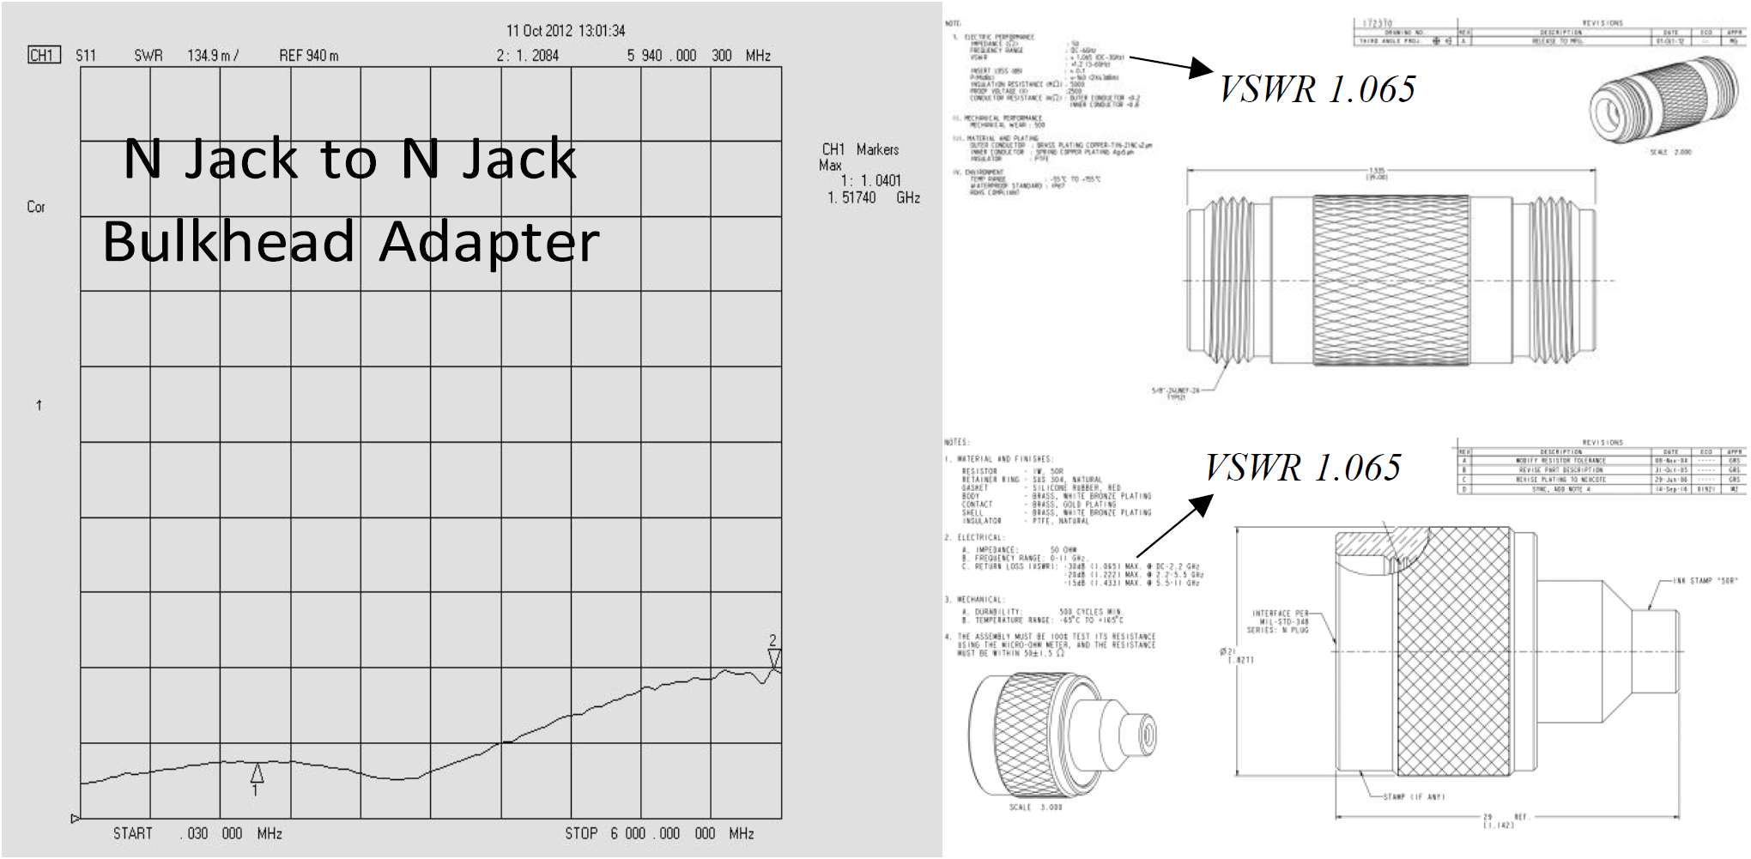

Figure 6. Typical reflection coefficient due to RF adapter is in the left graph. Adapter and terminator drawings are in the right.

The typical standing wave ratio degradation due to the reference item nonideality is 1.03 or 3% per each component (see Figure 6 for high-quality Amphenol parts). Such accuracy is sufficient for control the strip-line electrodes SWR with 5% tolerance. As an option at the stage of SAT the network analyzer may be calibrated with calibration kit provided by the manufacturer of NA. The dedicated reference load has long-term stability and precision better than 0.5%. Such kind of accurate measurements requires also at least one another high-quality termination at the upstream side of the antenna. This option is not available for Factory Acceptance Test due to the limited equipment possibilities of the contractor. Also, to make this test meaningful later on practice, one has to use the calibration quality terminators and signal cables for routine measurements of Schottky signals.

1. **Monitoring and Measurements**

**List and description of quality control steps**

The input tests of the procured products are performed to certify the compliance of procured raw material, components, facilities, measurement and test equipment to quality requirements of the procurement contract. The input tests are performed by the qualified personnel with requirements by *Regulation on the acceptance of goods, works and services in quantity and quality at ITEP*, approved by the Order of the Director №115, signed May 21, 2014. The input tests results are documented. The Quality certificates and material analysis’ documents are the part of the supplier’s documentation. The products accepted during the input test will be transferred to the storehouse or to the facilities. After detection of the non-conformances to the contract and quality requirements the products are registered in the non-conformance report. The non-conforming procured products are identified with a tag or label and shall be returned to supplier.

UHV tests should be done in accordance with *F-TG-V-7.1e “Mechanical Acceptance Test for UHV Components”*:

* Measurement of mechanical tolerances and documentation of measurement results in comparison to required dimensions;
* Measurements and documentation of required interface dimensions;
* Measurements and documentation of surface quality of the vacuum surfaces or reference surfaces;
* Measurements and documentation of surface quality of sealing surfaces;
* Documentation of material certificates of all produced components;
* Documentation of certified welders and welding certificates;
* Labelling of the flange material on the outer circumference of the respective flange;
* Each vacuum component must be labelled on the flange with a correspondent numbering. The labelling must be done by chemical engraving or impact stamping.

The geometrical parameters and disposition of fasteners (for example, for fiducial target or for transportation and lifting) should be checked in accordance with *F-TG-A-3.26e “Tolerance Diagnostics Chambers”*.

Moreover, all subsystems should be checked for their correct functionality.

**Process and criteria for final acceptance**

Control and tests are performed by the qualified personnel of Accelerator Center. If it is necessary, the specialists from the other departments are involved.

**Factory Acceptance Test (FAT)**

The tests performed by the ITEP’s facility shall follow the quality assurance procedures and requirements described in Section 5 of *F-CS-BD-01e “Common Specification Beam Diagnostics for FAIR”*.

The following dedicated tests must be performed:

* Check that the design is done according to the Conceptual design report and all parts are included
* Visual inspection and measurement of mechanical tolerances
* Mechanical Acceptance tests. All vacuum chambers must undergo a factory acceptance test according to manufacturing drawings, *F-TG-V-7.1e “Mechanical Acceptance Test for UHV Components”* and *F-TG-V-7.15e* *"Record for Factory Acceptance Test (FAT) of Vacuum Components"*.
* Vacuum requirements and acceptance tests:
  + Outgassing rate <= 5E-10 mbar/s/ ${cm}^{2}$ after 24h continuous pumping and pressure level less than 5E-7 mbar
  + Residual gas composition according to *F-TG-V-7.2e “Vacuum Properties Acceptance Test without Bakeout”*
  + Leakage rate < 1E-9 mbar/s for chambers with flanges for TIG welding connections and < 1E-10 mbar/s for chambers with bolted flange connections. All leak detection equipment, including any necessary additional assemblies and provisions required to perform qualified leak detection of the vacuum components, must be provided by ITEP. Leak test is carried out accordingto *F-TG-V-7.38e "Leak Detection of UHV Components"*.
  + The test procedure is described in *F-TG-V-7.2e “Vacuum Properties Acceptance Test without Bakeout”*
* Test on relative magnetic permeability of vaccum chamber and its elements like flanges, bellows and fixing elements (supports, bolts, nuts, washers, ...) must result in μr <= 1.05. The magnetic permeability must be measured along all welding seams at points with a distance of 20 cm and along the beam axis on top of the chamber at points with a distance of 20 cm. The vacuum firing/annealing (*F-TG-V-2.5e "Vacuum Firing for Hydrogen degassing of materials and UHV vacuum chambers"*) is allowed for decreasing relative magnetic permeability of stainless steel.
* Safety check. HV tests to exclude shortcuts to ground
* Characterization of all components of the measurement chain, e.g. noise figure, gain flatness, frequency responses, etc.
* RF measurements of the coupling impedances matching of the Schottky pickup, cross talks and transfer function measurement
* Test of the integrated software components for the control of the entire Schottky system
* Test of remote control for amplifier, RF switches state, RSA

FAT shall be prepared and performed according to the task list from Subsection 5.1.4 of *F-CSBD-01e “Common Specification Beam Diagnostics for FAIR”*:

* Availability of detailed specification description of the technical design;
* Preparation of detailed construction drawings;
* Production and assembly;
* Execution of required functional tests against all required system parameters;
* Availability of test results of first functional tests;
* Delivery and final installation in the facility.

For electronic parts, like low-noise preamplifier, rf switch, attenuator, amplifier, and controller or digitizer, certain QA measures shall be performed that are described in Section 5.2 of *F-CS-BD-01e “Common Specification Beam Diagnostics for FAIR”*. Installation of the preamplifier is foreseen at the CR tunnel inside the area with high radiation level, so preamplifier’s components and cables shall withstand a total energy radiation dose of 1 kGy.

**Site Acceptance Test (SAT)**

SAT will be performed by ITEP at the final location of the equipment according to Section 5 of “Common Specification Beam Diagnostics for FAIR” *F-CS-BD-01e “Common Specification Beam Diagnostics for FAIR”* including installation at the CR tunnel and commissioning of all components without beam.

They are spilt into two parts A and B, test prior to installation in the final location and tests after installation. Immediately after delivery, all components must pass a visual inspection (SAT Aa). Prior to installation, all component tests must be repeated in a dedicated test area to assure proper function and obtain the permission for on-site installation. This test area must have access to the accelerator control system infrastructure in order to allow for system integration tests. This SAT Ab process is finished and the approval for installation is given, if all test measurements are successful. After installation, the sequence of tests without beam (SAT Ba) is identical to the one of SAT Ab.

The tests will at least include:

* Verification of mechanical damages;
* Mechanical tests;
* Principal function tests;
* Long time test stability;
* Thermal stability test.

**Final Acceptance**

The Final Acceptance shall take place after the equipment delivery to the FAIR site and the Site Acceptance Test has been passed. The Final Acceptance will be formally documented by a Final Acceptance Protocol. The Final Acceptance Protocol will be issued by ITEP within five (5) working days and will be signed by both sides within thirty (30) days after the acceptance completion.

**Control of measurement tools**

The Head of the Vacuum and Instrumentation Service of ITEP’s Accelerator Center is responsible for metrological control.

The Heads of Accelerator Center departments are responsible for metrological discipline and available measurement and control equipment condition. All measuring and control equipment shall be recorded.

The procedure of procurement, recording, storage, inspection, calibration, repair, preservation and retirement of the control and measuring equipment is specified in the *Quality Manual РК СМК. 4.2.3-2013.*

Verification of measuring equipment is performed in appropriate inner or external accredited metrological services.

The ITEP Accelerator Center departments shall annually draw up schedules of periodical verification of measuring equipment which are approved by the Head of the Vacuum and Instrumentation Service and Head of QMS service. Measuring equipment not verified in due time and/or not providing the required measurement accuracy shall be withdrawn from use.

Calibration of measuring equipment is performed in appropriate inner or external accredited metrological services.

The ITEP Accelerator Center departments shall annually draw up schedules of periodical calibration of measuring equipment which are approved by the Head of the Vacuum and Instrumentation Service. Measuring equipment not calibrated in due time and/or not providing the required measurement accuracy shall be withdrawn from use.

The ITEP Accelerator Center departments shall annually draw up schedules of gages and indicators maintenance which are approved by the Head of the Vacuum and Instrumentation Service. Scope and type of maintenance are determined by working properties of the control instrument and usage specificity.

Before putting into operation measuring equipment is subjected to initial certification, and then certifications shall be performed periodically. Certification of measuring equipment is performed by specially assigned commission on-site according to a certification manual. The procedure of measuring equipment certification as well as duties and responsibilities of the Vacuum and Instrumentation Service and officials participating in certification are given in the *Quality Manual РК СМК. 4.2.3-2013*.

1. **Preservation of Products**

**Handling and storage specifications**

Procedures of product handling, storage, packing and delivery to the customer shall provide preservation of product quality obtained during its production. Requirements to product handling, storage, packing and preservation are specified in the technical documentation, specifications and the Collaboration Contract. The schottky pickup drawings provide load-gripping devices intended for lifting, transporting and canting. The product preservation and safe displacement requirements as well as product strapping and transportation are specified in the design documentation. The product preservation at ITEP site will be carried out under conditions to avoid any damage of the product.

**Packaging and transport specifications**

The schottky pickup shall be packed under conditions to avoid any damage of product during its storage at the ITEP site, transportation and storage at the FAIR site. The schottky pickup shall be packed for transportation under the conditions to avoid contact of product with rain water, spatter or condensates. The schottky pickup shall be safely fixed inside the wagon so that no damage and no decrease of the schottky pickup performance occur. Delivery procedure is specified in the project time schedule. ITEP will arrange the transportation and delivery of the schottky pickup to the FAIR GmbH in Darmstadt. Delivery shall be made on terms DAP Darmstadt (INCOTERMS 2010). They may be transported at any year season at a temperature from +30°C to -20°C and air humidity up to 95%.

The delivery address is:

FAIR GmbH

Planckstrasse 1

D-64291 Darmstadt

ITEP shall notify FAIR at least four (4) working weeks in advance of the scheduled delivery date. The delivery shall be made at FAIR premises at usual working hours to ensure finishing of all unloading works before the end of working day.

ITEP will inform FAIR about all devices required for safety transportation and field works before the beam position monitors delivery.

1. **Control of Document, Data and Records**

**List of documents and records**

The list of documents and records to be uploaded to EDMS for the Work Package PSP 2.5.6.3.2

*Manuals/Instructions*

* Quality plan (including measurements plan, control of measurement tools);
* Risk assessment;
* Installation and Operation manual (including installation, operation, troubleshooting, maintenance, storage, recycling and safety instructions);

*Drawings, Models*

* Digital 3D-models of the schottky pickup;
* Complete and approved set of production drawings of the schottky pickup;
* Complete and approved set of drawings of the components;
* Complete and approved set of drawings of tools and units;
* All released drawings, which are relevant to ITEP contribution;

*Certificates*

* Certificate for all components inside UHV (for high vacuum acceptance);
* Certificates of all materials being used for loading (crane eyes, setting areas, etc.);
* Welding certificates and welding instructions (including Strength analysis for welded joints; Acceptance certificate for welded products; calculation of all security-relevant welding joints (crane eyes, etc.) in a traceable form);
* Certificates for all 3rd party / commercial products or components (analog electronics, electronics components, vacuum feedthroug, etc.).

*Test protocols*

* Protocol set of the Factory Acceptance Tests (FAT);
* Protocol set of the Site Acceptance Tests (SAT);
* Set of Final Acceptance Protocols;
* Set of Quality Control Protocols;
* Storage/Transportation documentation for schottky pickup;

*Additional documents*

* List of personal information and project management structure;
* Time schedules;
* Minutes of meetings, reviews, evaluations, etc.;
* Relevant information exchange between ITEP and FAIR.

**Approval procedure**

Approval procedure shall be made according to requirements of the *F-DS-BD-34e_Special_SchottkyPickup_CR_v2.5_docx_cpdf* and *Quality Manual РК СМК. 4.2.3-2013.* During approval and inspection personnel shall fill Inspection Report which will be signed by Project Manager.

**Schedule of transmission to the Company**

ITEP will make and transfer periodic reports of activity progress which include manufacturing information. ITEP will submit full design documentation, material certificates, tests and measurements protocols, manufacturing and assembly documentation, information regarding special handling requirements together with delivery of schottky pickup to the FAIR GmbH. ITEP will immediate inform FAIR about any conditions which can cause parameters or schedule changes. All the changes shall be agreed with FAIR in accordance with changes control order.

**Ways of preservation of records**

Documentation is a part of the deliverables required according to the Collaboration Contract. The language to be used in all documents is English. Documents will be submitted to the FAIR GmbH in electronic form. The Engineering Data Management Systems (EDMS) will be used for all technical documents relevant to ITEP contribution. Released and approved documents are binding for both Parties. ITEP personnel is responsible for uploading and releasing the documents in the EDMS. Relevant access rights will be given to the ITEP responsible personnel.

1. **Control of Non-Conformity of Products**

**Immediate actions on defective products or product not suitable for its final functionality**

The non-conforming products shall be marked to prevent their undeliberate usage or delivery. When detected a non-conforming product shall be:

* withdrawn from a production process;
* recorded in the documents;
* identified;
* isolated;
* examined;
* registered and stored;
* modified, repaired, degraded, utilized, used according to the authorization for deviation or used for other purposes, sent back to the supplier in case of non-conformances detected in purchased products.

*Control of Nonconforming Product СТО СМК 8.3-2013* specifies the procedure of nonconforming product management as well as officials’ responsibilities and authorities to deal with non-conforming products. After detection of the non-conforming product a non-conformance report shall be issued and registered in the non-conformance report register by work shop specialists.

When detected the non-conforming product shall be identified with a tag or a label and isolated in a special room where non-conforming product preservation is in accordance with the technical documentation requirements and where the possibility of product unauthorized use is ruled out.

ITEP shall inform the FAIR GmbH within the period of two (2) working days of the detection of a non-conformance. The way of informing is the non-conformance report which shall be completed up to the column for approval of decision concerning the non-conformance and sent by email or fax to the Technical Coordinator. The treatment of the non-conformance shall follow the standard process established at the FAIR GmbH. All further actions which are taken according to the decision shall be recorded in the non-conformance report.

If the non-conforming products have been modified or repaired they shall be checked once again, and this check shall be recorded in the non-conformance report as well.

The procedure of cooperation in case of detecting non-conformances during the product input tests by the FAIR GmbH is stipulated by the requirements of the Collaboration Contract.

If ITEP delivers an equipment of an unsatisfactory quality, it has the obligation to remedy the deficiency at its own cost within an agreed time scale.

FAIR shall inform ITEP about detection of any product failure through the fault of ITEP during the warranty period. The warranty period for the equipment shall start at the day of transfer of ownership. The warranty period shall have duration of two (2) years.

**Corrective actions to eliminate the cause of the problem**

The corrective actions are taken at each stage of product lifecycle. All functions of the quality management system shall be carried out to eliminate the causes of non-conformances and prevent their reoccurrence.

Necessity of the corrective actions intended for eliminating the causes of the non-conformances is determined based on:

* product non-conformance reports when the non-conformances are detected during production as well as preliminary and final inspection and tests;
* customer’s claims (reclamations);
* results of internal quality management system audits;
* results of external quality management system audits.

The procedure of the corrective actions generally consists of:

* non-conformance analysis;
* detecting the cause of the non-conformance;
* specifying the corrective actions to be taken to eliminate the causes of the non-conformances;
* organizing and performing the corrective actions;
* supervising the corrective actions to estimate their effectiveness.

The Head of Accelerator Center authorized to solve the quality assurance issues is responsible for the corrective actions. The Heads of Accelerator Center Departments is responsible for the corrective actions control, results and effectiveness evaluation. *Control of Nonconforming Product СТО СМК 8.3-2013* specifies the procedure of the corrective actions concerning nonconforming products including purchased and delivered products as well as supervision over taking the corrective actions. The Heads of Accelerator Center Departments shall issue an account of detected non-conformances and corrective actions based on non-conformance reports as and when necessary. The account shall be sent to the Coordinator/Technical Coordinator for communication. The accounts of detected non-conformances and corrective actions are used for progress reports for the Collaboration Contract.

**Preventive actions**

Based on analysis of non-conformances relating to the QMS, effective steps shall be taken to prevent possible non-conformances of the products or procedures.

The following data sources may be useful in making the decision whether it is necessary or not to take a preventive action:

* procedures and operations affecting product quality;
* authorizations for deviation from the requirements of design and manufacturing documentation;
* inspection results during production;
* inspection and test reports during product manufacturing including the input tests of procured materials, half-finished products and components;
* data on customer satisfaction relating to the product quality;
* customer reclamations.

The preventive actions include development of measures intended for prevention of conditions and causes of possible non-conformances negatively affecting the quality. These measures involve:

* revision or development of new quality assurance documents;
* replacement or procurement of new production resources;
* replacement of suppliers providing defective or low-quality products;
* drawing up the list of especially important manufacturing processes and their practicing;
* application of new techniques and new manufacturing equipment;
* regular manufacturing accuracy checks of equipment;
* supervision of manufacturing discipline;
* strengthening supervision of design and manufacturing documentation;
* use of calibrated and/or verified measuring equipment and certified test equipment for product inspection and tests;
* involvement of highly skilled specialists in product manufacturing;
* personnel training, retraining and advanced training.

The procedure of taking and monitoring the preventive actions is stated in *Corrective and Preventive Actions СТО СМК 8.5-2013*. Data concerning the preventive actions which have been taken shall be analyzed in order to estimate effectiveness of these actions and systematically submitted to the ITEP administration.

1. **Professional Quality and Certification of Personnel**

The level of ITEP personnel competence required for execution of the Collaboration Contract including awareness of laws and standard documentation is specified in ITEP Department regulations.

The Heads of the Departments are responsible for selecting specialists of required qualification and providing their training and advanced training. To obtain and retain the required professional competency and skills the training and retraining for personnel related to quality assurance are carried out. The personnel trainings covers all levels: administrators, specialists, workers. *Quality Manual РК СМК 4.2.3-2013* is specified the order of personnel training as well as recording and data storage of training. The Heads of the ITEP Departments determine the personnel categories and specific specialists who should be certified by supervisory authorities. The Heads of the ITEP Departments make the final decision concerning certification of personnel and specific specialists.

1. **Assistance: Technical Support to the Company**

FAIR/GSI personnel will have an access to all relevant information and data. FAIR/GSI personnel have the right to inspect the work under the Contract at the premises of ITEP and of its subcontractors at any working time. FAIR/GSI must inform ITEP about the visit at least five (5) working days in advance.

1. **Internal Quality Audits**

Internal quality audits will be performed in accordance with QMS documented procedures defined in the *Audits СТО СМК 8.2.2-2013*. Audits will be performed by the QMS service staff, all employees of which have certificates of Internal auditors.

**Annex**

This Annex and all herein listed and cited documents and regulations are an integral part of the Contract between the Contracting Parties.

**Annex 1**

**ISO 9001:2015**

Certificate of conformity of NRC “Kurchatov Institute” - ITEP to ISO 9001:2015.

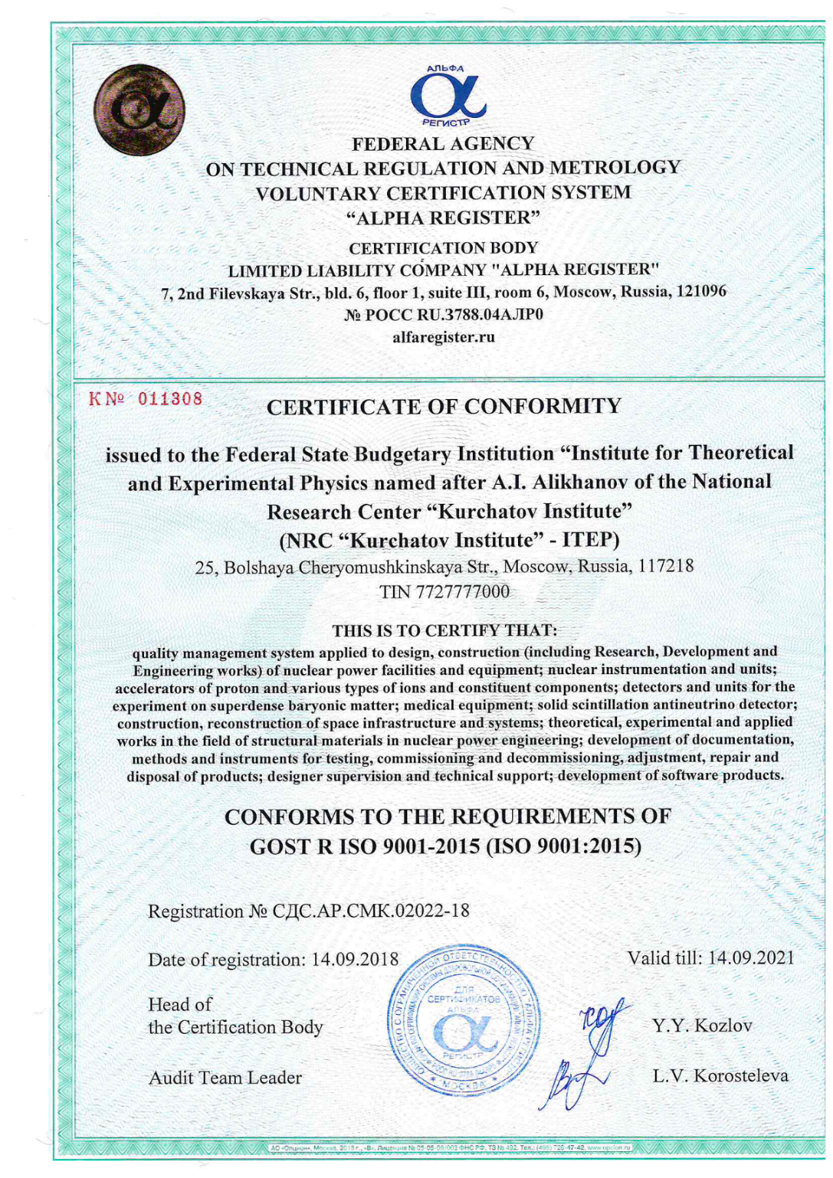

**Annex 2**

**Specifications and Guidelines**

Component: Tune and Longitudinal diagnostics, Schottky Pickup for CR (PSP 2.5.6.3.2)

**General Documents [1…5]**

[1] TDR-CR, Technical Design Report on the Collector Ring (CR)

[2] F-GS-F-01e-General_Specification, General Specification (General Specification for the FAIR Accelerator Facility Project)

**Common Specifications [10..19]**

[10] F-CS-BD-01e_Beam_Diagnostics, Common Specification Beam Diagnostics for FAIR

[11] F-CS-RF-5e_Electronics_Specifications

**Detailed Specifications [20...23]**

[20] F-DS-BD-40e DAQ

[21] F-DS-C-05e_General-Machine-Timing-System

[22] F-DS-C-06e_Timing-Receivers

[23] F-DS-BD-44e_mech_vacuumchambers_HEBT

**Development Guidelines [30…35]**

[30] F-DG-C-01e_FESA-Development-Guideline

[31] F-DG-C-02e_GUI-Guideline

**Technical Guidelines [100..199]**

[100] F-TG-V-2.1e_Stainless_Steel_for_Beam_Vacuum_Chambers

[101] F-TG-V-2.19e_Additives_for_TIG_Welding_of_Stainless_Steel

[102] F- -TG-V-2.36e_Bolts_Studs_Nuts_Washers_for_non-bakeable_UHV_Components

[103] F-TG-V-2.24e_Materials_in_UHV

[104] F-TG-V-2.25e_Forged_Blanks_for_Vacuum_Applications_Material_1.4429_ESU

[105] F-TG-V-2.5e_Vacuum_Firing

[106] F-TG-V-3.1e_Constructive_Design_of_Welding_Seams_for_Vacuum_Chambers

[107] F-TG-V-3.4e_Manufacturing_of_CF-Knife_Edge_Flanges

[108] TG-V-3.41e_COF_Gaskets

[109] F-TG-V-3.42e_Copper_Gaskets_for_ConFlat_Flanges

[110] F-TG-V-3.9e Welding of CF-Flanges on Tubes

[111] F-TG-V-5.1e_Surface_Conditions_of_Vacuum Chambers

[112] F-TG-V-6.1e_Cleaning_of_UHV_Components_Stainless_Steel

[113] F-TG-V-6.2e_Cleaning_of_Standard_Vacuum_Components

[114] F-TG-V-6.3e_Cleaning_of_Bellows_Used_in_Beam_Vacuum

[115] F-TG-V-7.1e_Mechanical_Acceptance_Test_for_UHV_Components

[116] F-TG-V-7.15e_Record_for_Factory_Acceptance_Test_(FAT)_of_Vacuum_Components

[117] F-TG-V-7.2e_Vacuum_Properties_Acceptance_Test_without_Bakeout

[118] F-TG-V-7.38e Leak Detection of UHV Components

[119] F-TG-8.18e_Recommended_Guidelines_for_Purchase_of_Vacuum_Chambers_ CR

[120] F-TG-V-9.1e_Transport_and_Packaging_of_Vacuum_Components

[121] F-TG-V-9.12e Sealing Cap for CF Flanges

[122] F-TG-V-9.4e Transportation by air cushions

[123] F-TG-V-10.14e Documentation of Results from Mechanical and Thermo-Mechanical FEM-Simulations

[124] F-TG-B-01e_Material_Selection_Radiation

[125] FAIR Technical Guideline, F-TG-B-02e DARL-T1, “Datenaustauschrichtlinie”

[126] FAIR Technical Guideline, F-TG-B-03e DARL-T2, “Datenaustauschrichtlinie”

[127] FAIR Technical Guideline, F-TG-MDS-en-KRL, Konstruktionsrichtlinie (KRL)

[128] FAIR Technical Guideline, F-TG-S-2.17e General construction norms

[129] F-TG-ET-01e_Electrical_Design_Rules_and_Regulations

[130] F-TG-C-01e_Ethernet-Network-Connectivity

[131] F-TG-C-02e_Control-System-Equipment-Interfaces

[132] F-TG-T-01e_Transport

[133] F-TG-T-02e_Existing_Infrastructure

[134] F-TG-T-03e_Installation

[135] F-TG-B-0.5e_CID_and_Barcode

[136] F-TG-S-3.51e Non-modular individual stand_steel

[137] F-TG-S-3.50e Alignment bridges

[138] F-TG-A-3.55e_Layout_of_a_fiducial_target_seat

**Special Documents and Technical Notes [200...]**

[200] V. R. Schaa, F. Peldzinski, M. Kühne and Bayer, Wolfgang, "System for Nomenclatures of Accelerator Devices at FAIR & GSI," [Online]. Available: https://wwwacc.gsi.de/wiki/Accnomen.

[201] S.Chattopadhyay, Some Fundamental Aspects of Fluctuations and Coherence in Charged-Particle beams in Storage Rings, CERN Yellow report 84-11, October 1984

[202] D. Boussard. Schottky Noise and Beam Transfer Function Diagnostics, CERN SPS : 86 (1986).

[203] R. Singh et al. , Understanding The Tune Spectrum Of High Intensity Beams, Proc.of IBIC 2013, p.941, Oxford, UK

[204] King-Yuen Ng, Impedances Of stripline Beam-Position Monitors, Particle Accelerators, 1988, Vol. 23, pp. 93-102

[205] A. Blednykh#, W. Cheng, S. Krinsky, Stripline Beam Impedance, Proceedings of PAC2013, Pasadena, CA USA

[206] G.R. Lambertson, “Dynamic Devices-Pickups and Kickers,” in Physics of Accelerators, eds. M. Month and M. Dienes, AIP conf Proc. 153, 1414 (1987).

[207] D. A. Goldberg and G. R. Lambertson, “Dynamic Devices a Primer on Pickups and Kickers” LBL-31664, Nov. 1991.

[208] F. Nolden, Instrumentation and Diagnostics Using Schottky Signals, Proceedings DIPAC 2001

[209] J. Bosser, Beam Instrumentation, CERN-PE-ED 001-92

**Annex 3**

**List of abbreviations**

|  |  |
| --- | --- |
| CC | Collaboration Contract |
| CR | Collector Ring |
| DQS | Deutsche Gesellschaft zur Zertifizierung von Managementsystemen |
| EDMS | CERN Engineering Data Management System |
| FAIR | Facility for Antiproton and Ion Research in Europe GmbH |
| FAT | Factory Acceptance Test |
| GSI | German: GSI Helmholtzzentrum für Schwerionenforschung mbH/  Helmholtz centre for heavy ion research |
| ISO | International Organization for Standardization |
| ITEP | NRC «Kurchatov Institute» – ITEP |
| PSP | Project Status Plan (element) |
| QP | Quality Plan |
| QMS | Quality Management System |
| SAT | Site Acceptance Test |
| Working day | Are all days from Monday to Friday except the Russian holidays |